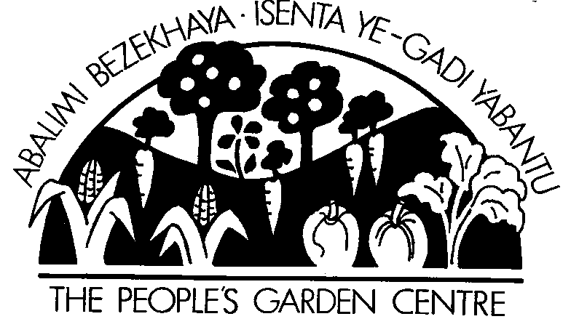
P.O Box 44 Observatory, 7935, Cape Town, South Africa
Ph/Fax :021-371 1653
email : info@abalimi.org.za
Web-site: www.abalimi.org.za
015-337 NPO

Last updated: March 2008

1. OVERVIEW:

Context The Cape Flats townships are the “Eastern Cape on Cape Town’s doorstep”, populated largely by economic refugees from the previous apartheid homelands of the Ciskei and Transkei. New arrivals into Cape Town are officially estimated to be 1200/month. Unemployment figures continue to be in the region of 30%-40%. Abalimi Bezekhaya (the planters of the home) attempts to alleviate poverty and create self-employment through gardening and micro-farming in the townships of Cape Town.

History & Legal Status: ABALIMI BEZEKHAYA (the Planters of the Home), founded in 1982/83, is a Voluntary Association registered as a Non Profit Organisation (NPO) with the Department of Social Development (S.A.).

Mission Statement: Abalimi Bezekhaya is an NPO working to improve sustainable food production and environmental greening amongst the poor in Cape Town. Our focus is on skills development through training and supporting people and organisations who wish to practice organic horticulture and micro farming. We promote sustainable development while encouraging initiatives which renew, build and conserve social organisation, self responsibility and the natural environment.

Infrastructure, Staffing & Target Group: ABALIMI runs an administrative office in Phillipi and works out of two non-profit Garden Centres/nurseries in Khayelitsha and Nyanga. The majority of the core staff are women and are recruited directly from our Target Group. We currently have a core full time staff of (up to) twelve , and part-time, contracted or casual staff of (up to) 13 persons at any one time. Only three staff members are entirely administrative. Everyone else, including management level staff - are directly involved in project delivery to our Target Group in the field.

Target Group – the disadvantaged, the poor and the unemployed. In particular, women, mothers and grandmothers are our main target group, not because we exclude anyone else, but because it is mainly they who come forward and actually carry the impulse of gardening and micro-farming in the townships. Women, mothers and grandmothers more often than not represent whole families, thus the direct impact of our work goes well beyond individuals.

Key Result Areas (KRA’s) : ABALIMI accounts for its core activities under seven Key Result Areas, as follows…

KRA 1. Project Implementation: ABALIMI supports individual households and groups to implement own gardening and micro-farming projects. This includes between 300-1000 home based vegetable gardens per annum and 50 community group projects (school gardens, community gardens, communal gardens) per annum .

KRA 2. Resource Supply: ABALIMI runs two non-profit nursery projects in Nyanga and Khayelitsha. These are called People’s Garden Centre’s and they supply free advice, information and subsidised gardening inputs such as trees, groundcovers, soil improvers (e.g.: manure), seed, seedlings, basic tools, windbreaks and safe pest control remedies to our Target Group.

KRA 3. Training: we train up to 1000 people each year through 4-day Basic organic vegetable growing courses, year-round on-site technical follow-up support visits and demonstrations to projects, and the agri-Planner training game – this game was developed (with Abalimi’s assistance) by the South African Institute for Entrepreneurship (SAIE). It is a special business training programme for even illiterate people, in the form of a game which instructs trainees on agri-business principles and practices for vegetable gardening. This unique training game is now being rolled out in Cape Town and nationally.

KRA 4. Community Building: the social benefits of organic gardening and micro-farming among the poor are enhanced through activities such as:
* iLIMA- mutual help work events where members from different community projects gather and work together on one community project site to accomplish large or difficult tasks. iLIMA is always accompanied by good food and celebration at the end of the day, radiating goodwill out into the surrounding community.
* Horizontal (farmer to farmer) Learning events- this is where the gardeners and farmers gather to share stories, difficulties, problems, solutions and achievements among themselves. These events are highly motivating and result in greater efforts to self-improve.
* Savings Mobilisation – every community garden project which works with ABALIMI must open a project savings account if they want to make use of ABALIMI’s marketing projects for their organic produce. Community project savings is a good foundation for further development. See Point 2 PROJECT TYPES for more information on Marketing Projects

KRA 5. Partnerships and Networking: ABALIMI, through its own partnerships and networks, assists community projects to connect to other opportunities and services which they may require. For example, a community garden group may wish to start up a sewing group, or obtain support from another service provider. ABALIMI points the community projects in the right direction and often helps to make the connections. Furthermore, ABALIMI incubates or hosts cross-cutting Special Purpose projects which enhance our core business and these Special Purpose projects are seen as “internal partners” until they become independent and/or autonomous of ABALIMI, or become incorporated into ABALIMI. A list is provided below under Point 2- Project Types..

KRA 6. Research, Monitoring and Evaluation (M + E): ABALIMI has hosted or collaborated with many researchers over the years and continues to do so. ABALIMI utilises the results of this research to fine tune its own development practice, so that community projects become more and more sustainable within a better defined step-by-step process. ABALIMI has developed a unique Development Continuum and Sustainability Index framework which is able to track sustainable development of community projects along a clear pathway. The development continuum proceeds through four phases. Projects can remain in each phase permanantly or move backwards and forwards between phases, depending on circumstances. The phases are: Survival Level, Subsistence Level and Livelihood Level and Commercial Level. More information available on request.

KRA 7. ABALIMI’s Organisational and Financial Sustainability: This internal Key Result Area focuses on ABALIMI’s legal, general and financial management/development, human resources, fundraising and communication functions. ABALIMI exists to deliver to its Target Group and must ensure that everything possible is done to ensure its health and efficiency in order that it can fulfil its mission.

Growth in demand for our services: An average of 25 new applications from community groups for help with their gardening and micro-farming projects is recieved by ABALIMI every year.

Accounting & Financial Statements: ABALIMI is audited annually by MGI Bass Gordon. Financial statements are available on request.

Funders/donors: ABALIMI is fortunate to have a loyal range of Friends- funder and donor partners, international and local, who ensure that our work continues. As our work grows, however, we must continually build new relationships with prospective donor and funder partners. ABALIMI’s policy as a Non Government Organisation (NGO) is to avoid reliance on Government funds for core costs, although we do utilise such funds when available for specific projects. A full donor list (over 200 per annum) is included in the latest Newsletter and in the financial statements.

2. Typical PROJECT TYPES & AVERAGE COSTS:

- Community Gardens on council land and on school grounds : Size ranges between 1000m2 to 5000m2 or larger. ABALIMI offers support with planning, capital developments, installation of plant & equipment, training, soil inputs, seed and plants and follow-up over an initial three year period. If a community garden site has no infrastructure, we budget up to R100m2/annum over three years, inclusive fertility stabilisation, planning, capital installations, plant & equipment, training, organisation building and follow-up. ABALIMI-supported urban organic community gardens are the first to have proven that permanent livelihoods can be created on micro projects, while conserving and promoting indigenous flora. A 1000m2 community garden currently costs approximately R100 000 in total to set up over a three year period. A minimum of two sustainable family livelihoods can be created on 1000m2.

- Household Survival and Subsistence Gardens: the foundation of our target group are pure survivalists, who “temporarily” engage in vegetable production at home until a “job comes along”. By supporting such individuals to survive and subsist through gardening, we are also inculcating an emerging organic gardening culture which is becoming a permanent feature of the urban environment among the poor in Cape Town. The skills learned by survival and subsistence gardeners remain with them, even if they stop “when they get a job” and can be drawn upon again in future. ABALIMI provides training, advice and subsidised start-up inputs to survivalists. It costs up to R1750/household to establish a viable organic household vegetable garden - this cost is mainly for training and follow-up but includes a start-up pack. ABALIMI offers full subsidies to indigent households, who comprise the majority of our client/target group. Usually, however, we obtain a token payment for the training, in the form of a R30 registration fee.

- Community Greening projects: Tree Planting carries on year round, although we focus on the Autumn/Winter season (May-July) in Cape Town, as the winter rains help a great deal in establishment of trees. Cape Flora is our priority and we do not plant invasive exotics. It costs R125 to plant one tree, with training and follow-up. Trees are planted mainly in community gardens as windbreaks, but also (on request) in community institutions such as educares, community centres and schools where applications for support from these institutions have been received and approved.

- Special Purpose projects within ABALIMI (“internal partners” ) :

Surplus marketing project: launched in 2007, after a trial period in 2006, this project identifies and sells on a weekly basis surplus produce from subsistence gardens (produce which cannot be easily sold inside the townships) to the wider market outside of the townships.

Harvest of Hope project: launched in Feb 2008, the Harvest of Hope project utilises a small Pack Shed to collect, pack and deliver organic vegetable boxes to families in Cape Town. This project offers regular income security to the community farmers, by contracting them to grow seasonal organic produce at guaranteed prices. Families at rich schools in Cape Town sign up in advance to buy Harvest of Hope boxes. For more information contact harvestofhope@abalimi.org.za

Moya we Khaya: means “Spirit of Home”. This is a unique community and environmental centre which is being led by Christina Kaba, chairperson of the famous Manyanani Peace Park. Moya we Khaya is being developed as a pan-african intergenerational cultural community home, which gives everyone - women, elders, youth and men – a healthy and related place in the community and in nature. For more information contact info@abalimi.org.za

- Independent Special Purpose project partners/associates, originally born or nutrured in ABALIMI :

The Schools Environmental Education and Development (SEED) project is working with teachers to infuse Environmental Education into all teaching practice at foundation phase, incorporating and developing the outdoor classroom as the main teaching resource. Contact: admin@seed.org.za Website: www.seed.org.za

Jungle Theatre project is an environmental street theatre group who, among other exciting things, also focus on integrating drama with tree planting, gardening. Jungle Theatre integrates the value of the natural environment and conservation through traditional wisdom and story-telling. Contact: info@jungletheatre.co.za Website: www.jungletheatre.co.za

3. AWARDS:

ABALIMI, its projects and staff members have collectively received 15 national and international awards since 1991, including three Green Trust-WWF awards, two Presidents Social Forestry awards, Woman of the Year award, a Paul Harris Fellowship, an Ashoka Fellowship and the Khayelitsha Achiever Award for Community Development .

